SPONSORSHIP REQUEST
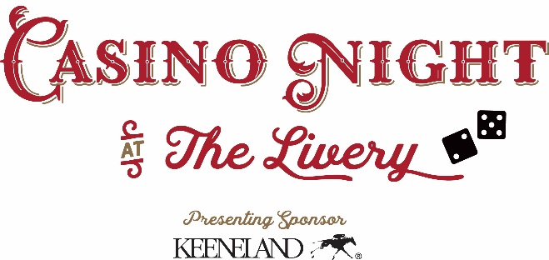

Friday, September 27, 2019 – The Livery, 242 Water Street, Lexington

Casino Night at the Livery is a fun evening with drinks, heavy hors d’oeuvres, jazz music, live and silent auctions and casino games. We hope to see many of our friends and colleagues from the Thoroughbred industry at the party. Listed are the levels of sponsorship for your consideration. We thank you for your help in sustaining and growing Blue Grass Farm Charities’ impact on the Thoroughbred industry of Central Kentucky.
__________________________________________________________________________________________

All Levels Include: Company logo displayed throughout the event; company logo “thank you” recognition on BGFC Website with link to company Web page; and ‘thank you” recognition in BGFC’s Across the Board Newsletter.

Platinum Level - $5,000
A full-page color ad in the event program, company logo on mobile bidding platform, and 16 complimentary tickets for you and your guests.

Silver Level - $3,500
A half-page color ad in the event program, company logo on mobile bidding platform, and 12 complimentary tickets for you and your guests.

Bronze Level - $2,000
A quarter-page color ad in event program, and 8 complimentary tickets for you and your guests.

***************************************************************************************************************************
Sponsorship Agreement Form

Billing Address/Information:  Business/Farm/Organization  Name: ________________________________________  Address: ______________________________________  Phone: _______________________________________  Email: ________________________________________  Sponsor Level: __________________________________  Contact: ________________________ Date: _________ | Payment Method:  Check Enclosed: ______ Bill Me: _______  Type of Credit Card -  Visa ______MC ______Am/Ex _______Discover _____  CC#: _________________________________________  Expiration: __/___/___ Security Code: __________  Printed Name on Card: __________________________  Signature: ____________________________________

Please complete form stating your level of sponsorship
Fax or scan to: info@bgfcky.org -- Or send in the enclosed envelope to 340 Legion Dr., Suite 20, Lexington, KY 40504
Phone 859.219.0190 Fax: 859.219.0670 www.bgfcky.org

